Ultrasonic tube washer Project May 22, 2014

Markin Tubing in Wyoming, NY produces carbon steel tubing and either copper coats or galvanizes the tubing, thin wall, most are .053" wall thickness. They form the tube from flat metal and process it in-line at 200' a minute to form the tube, weld and heat treat. Tube diameters range up to 1 1/2".
The tube enters a wash tank which is set for 140 degrees and they use Oakite 12 soap. The next stages are two radial ultrasonic units, then ambient rinse and air knife. They use RO water in the system.
Recently they added a magnet at the bottom of their filtration system (single tube) to help catch metal flakes to reduce adhesion issues. They replace filters once a week.
The tube is then reheated to glowing red/purple, quenched and they coated with either copper or galvanized zinc mixed alloy. Tubing is then coiled and shipped to customers - a portion of their market share is automotive.
They have 3 lines with ultrasonic cleaners and currently need to replace 2 of the systems.
The units are a combination of branson ultrasonics and units produced by Mangus in Willoughby, Ohio.
They have several issues with the Magnus systems.
1. Over time the poly tanks become brittle and are difficult to repair when they leak.
2. The Ultrasonics have spikes in cleaning which affects adhesion of the galvanizing.
3. O rings bread down quickly in the ultrasonic systems
4. Poor service response from Magnus

I'm told a unit with 2 radial ultrasonics is $125k from Magnus - don't know how accurate that is.
They want a stainless steel tank system and a better, more reliable ultrasonic system.
Both units need to be replaced before the end of the year so this is a high priority project with 2 production lines that need to increase in productivity and reduce waste due to adhesion/cleanliness problems.

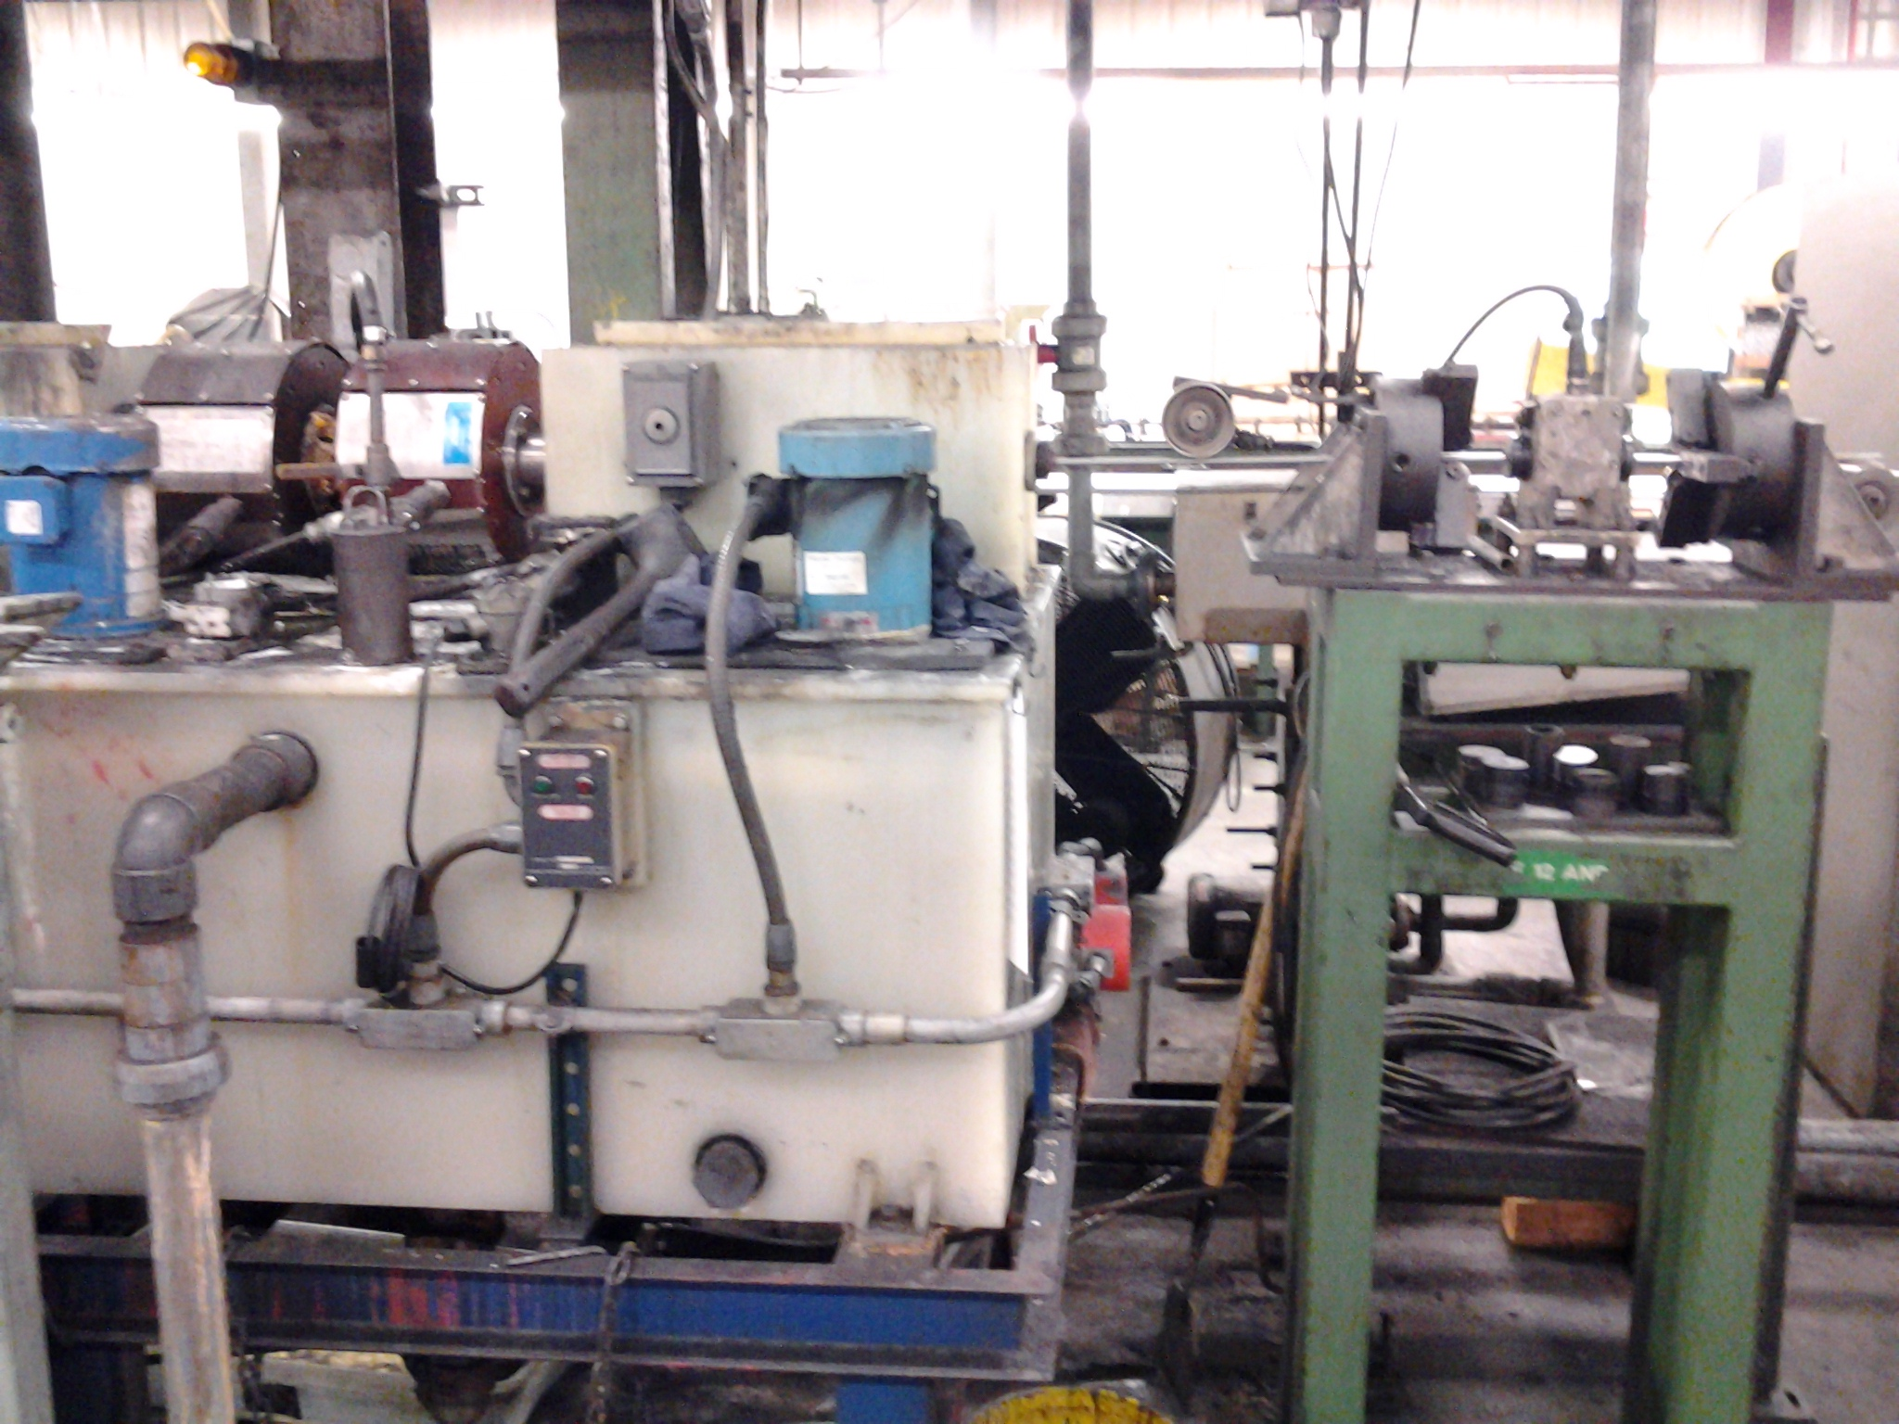
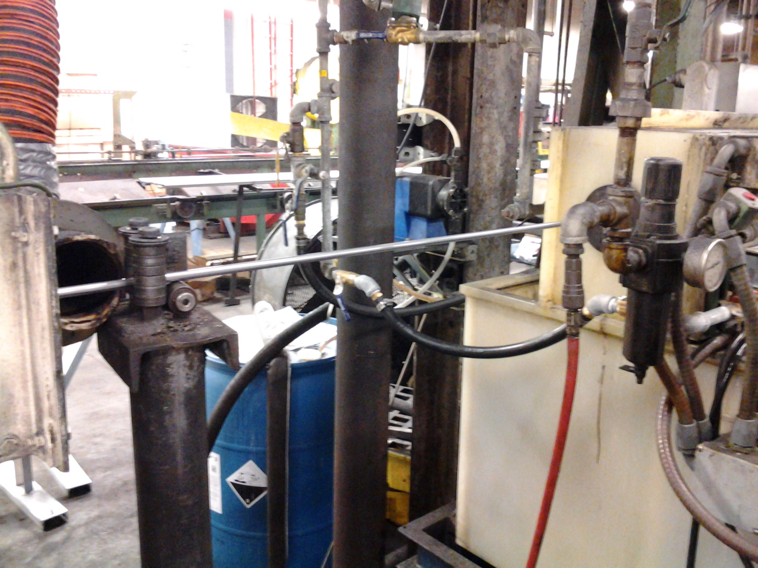
Wash
Radial ultrasonic units
Rinse tank and air knife blow off

